The Atlantic Chapter of the Canadian Land Reclamation Association (CLRA) and the New Brunswick Community College (NBCC) are again joining forces and co-hosting ARC2019

NATURAL PROCESSES FOR THE RESTORATION
OF DRASTICALLY DISTURBED SITES
Course Instructor David F. Polster; R.P. Bio.
International expert in plant ecology with over 40 years of experience in restoration ecology

Dates: May 14-15, 2019
Location: Day 1: NBCC, Moncton Campus (1234 Mountain Road)
Day 2 Saint Marie Community Pasture Restoration Project

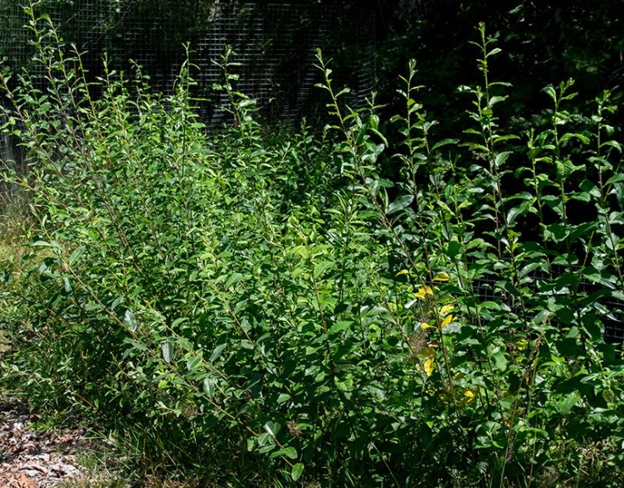
Description:
This riparian restoration workshop will use live plant materials, rocks, soil and landscape elements to perform an engineering function such as slope stabilization, soil erosion control or seepage control.

Topics to be covered include:
Live staking - taking live cuttings of shrubs and planting them in the ground where there is a lack of vegetation
along eroding stream banks. The clippings will re-sprout and establish new vegetation.
Wattle fences - used to treat steep slopes via terracing, reducing erosion while the living cuttings grow to provide a vegetative cover on the slope.
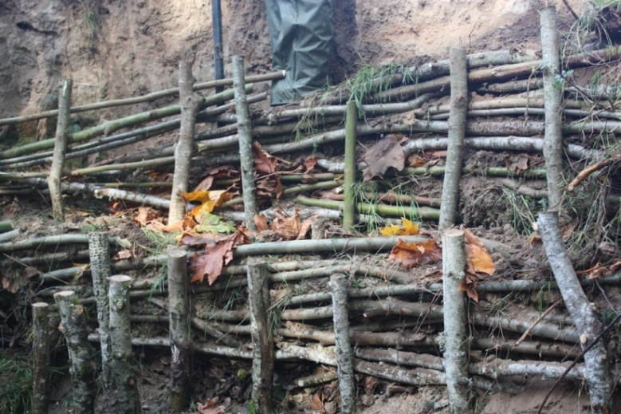

Registration will be limited.
Pre-registration required!
Registration form: www.atlanticclra.ca
Send registration form to: Atlantic@clra.ca
Cost: $75 for CLRA members, $150 for
non-members, $50 for students
For additional questions, please contact Vicki at:
vicki.nash@clra.ca or (506) 478-0741

Agenda
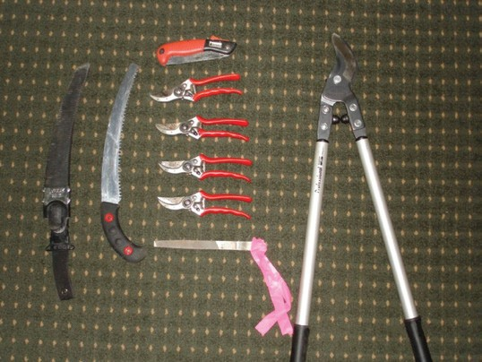
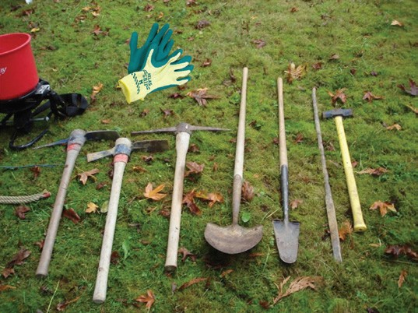
DAY ONE: Tuesday, May 14
If you have any of the tools in the pictures below, please bring them to use on the field days. Make sure you label your tools with your name.
NBCC Community College, Moncton (Bring a notebook and pen; course manual and lunch are provided)
Registration/ Coffee- 8:30am
Start Time: 9:00am
- Objectives
- Format of the session
- Factors involved in successful restoration
- Landforms, climate, soils, vegetation
- Successional reclamation
- Site preparation
- Coffee Break
- Soil bioengineering techniques
- Species selection, collection, handling, and storage
- Soil bioengineering treatments
- Water management techniques
- Use of natural processes Noon - Lunch (Provided) 1:00 pm – 5:00 pm
- Soil bioengineering treatments continued
- Habitat improvement techniques
- Maintenance and monitoring
- See hotel recommendations for May 14 on
information sheet

DAY TWO: Wednesday May 15
Meet at Auberge Bouctouche Inn and Suites (30 min. from Moncton) at 8:30 am
(Bring rain gear, work gloves, rubber boots, safety vest, plenty of water and any tools you have – see photos on right of page. Additional safety gear including hard hat, goggles, sunscreen and bug spray recommended.)
- Harvesting Plant Materials Details to be arranged on Day 1
Noon (approx.) – Lunch (Provided)
- Hands-on bioengineering in the field
- Wrap up between 4:00 – 4:30 pm

